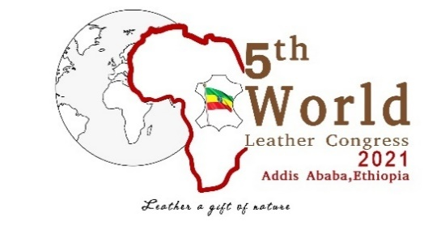
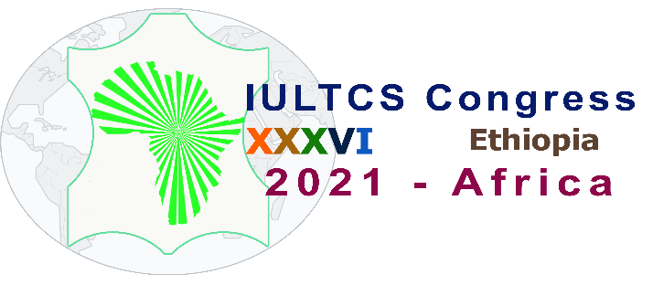

XXXVI IULTCS AND 5TH WLC BIENNIAL CONGRESSES 2021 IN ADDIS ABABA, ETHIOPIA

PRESS RELEASE

The XXXVI International Union of Leather Technologist and Chemists Society (IULTCS), and the 5th World Leather Congress (WLC), hosted by the Africa Leather and Leather Products Institute and the Ethiopian Government, will be held in Addis Ababa, Ethiopia, from 1st to 5th November 2021 at Skylight Hotel.
Over 300 scholars, researchers, experts, leather and leather products manufacturers and investors from over 50 countries around the world will attend the two high level Congresses to discuss pressing issues affecting the leather sector, advancement of the leather science and technology, and networking within the leather industry.
IULTCS, a worldwide organisation of professional societies, has held its previous 35 Congresses in nineteen different countries on five continents. In 2021 the IULTCS will add another new country when the Congress will be held in Ethiopia with the theme of "Greening the Leather Value Chain”.
The prestigious keynote lecture of the Congress, the Heidemann Lecture, will be delivered by Professor Anthony Covington, winner of the IULTCS Merit Award for Excellence in the Leather Industry in 2009, and the Alsop Award for Outstanding Scientific Contribution to the Leather Industry from the American Leather Chemists Association in 2011. He was also awarded the world’s very first Doctor of Science (DSc) degree in Leather Technology in 2010, by the University of Northampton.

The World Leather Congress has held its previous four congresses in Brazil (Rio de Janeiro 2011), Europe (Milan 2015), China (Shanghai 2017), and the United States of America (New York 2019) with the 5th being hosted by the African Continent. The theme of the 2021 congress is “Leather a Gift of Nature”.
Both the XXXVI IULTCS Congress and the 5th WLC are HYBRID events, providing participants the options of attending either physically or virtually.

For more information please visit
https://www.iultcs2021africa.org/home
or
https://www.allpi.int/
CONTACT:
Ethiopia: executive.director@allpi.int
International: info@tradeandfairs-consulting.com

